

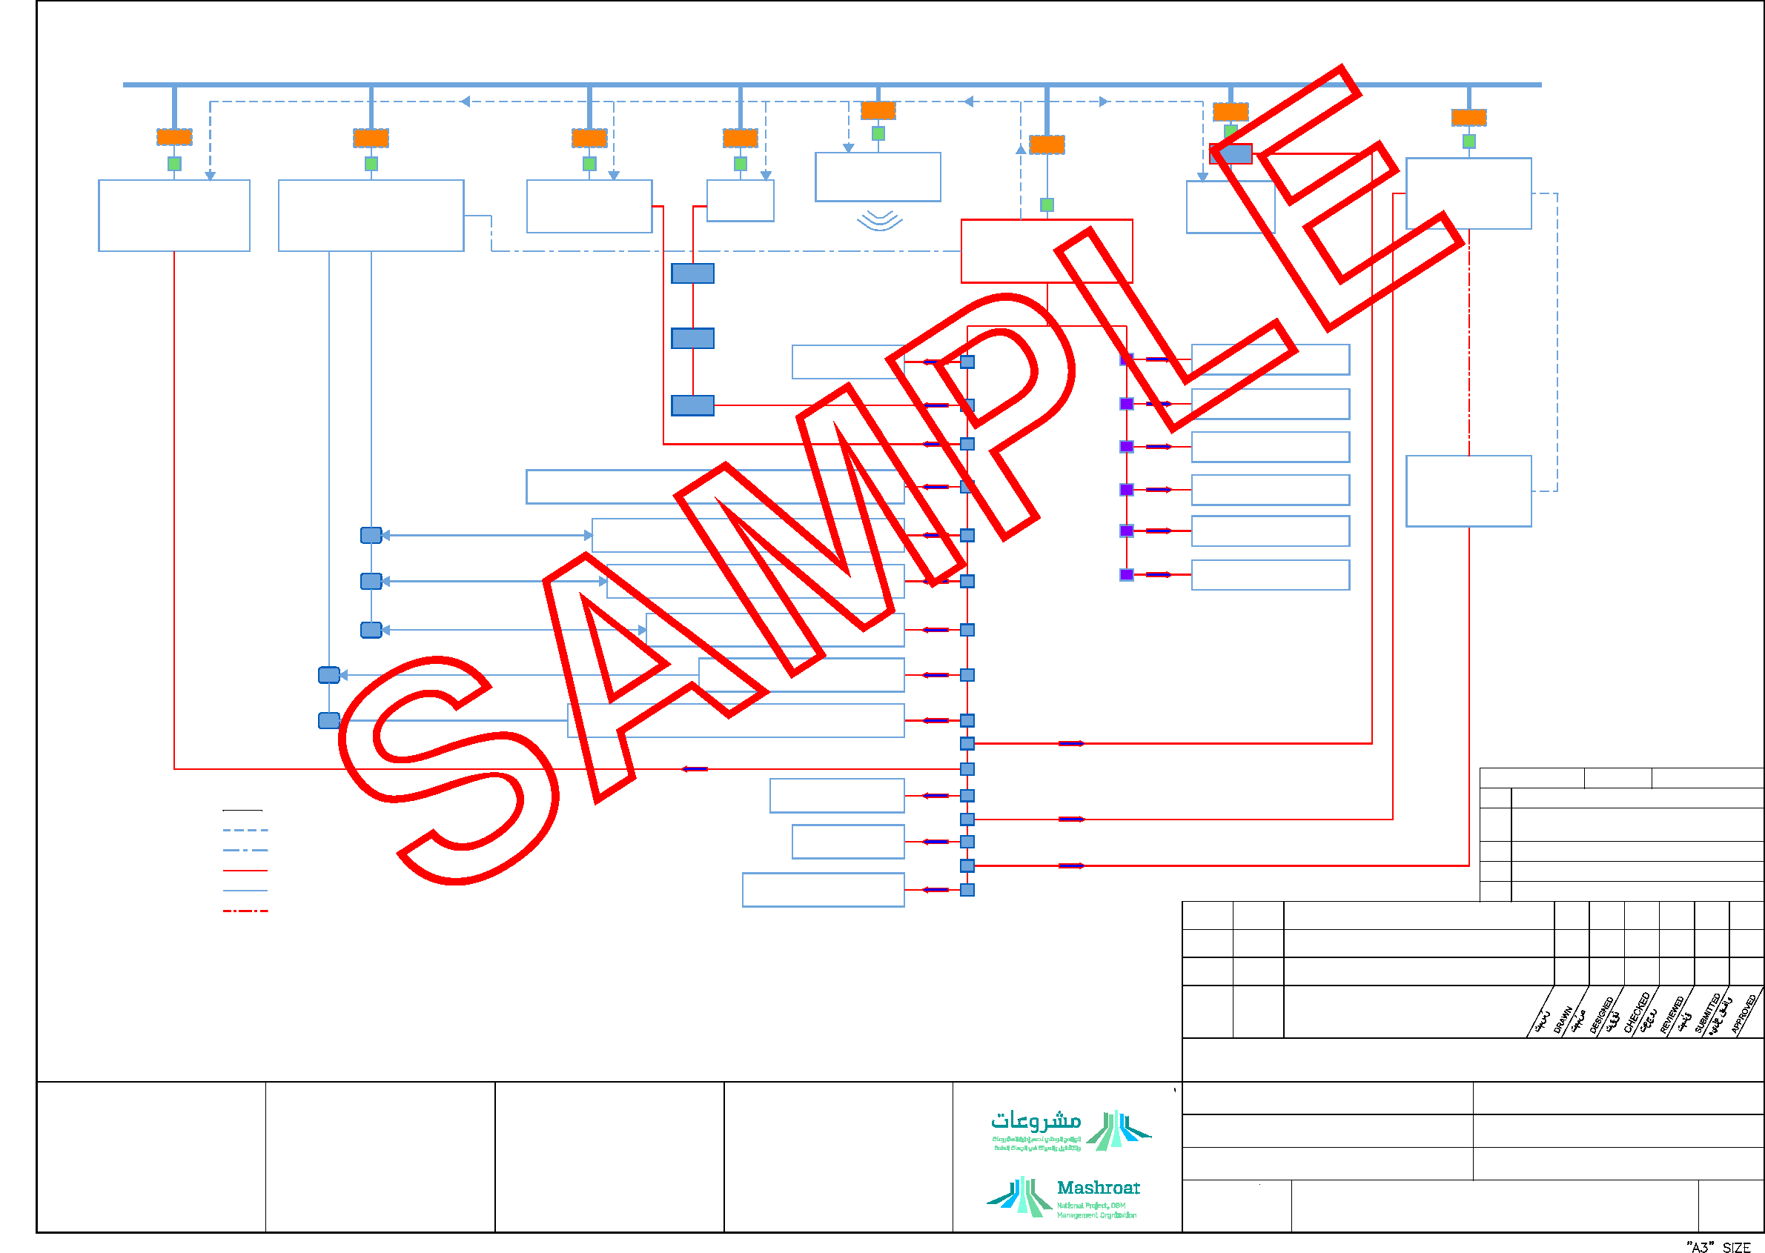
SCALE
NTS
REV
002
DRAWING No.
ARABIC TITLE
ARABIC TITLE
KINGDOM OF SAUDI ARABIA راممقكم راراقم رسمللم
PROJECT REFERENCE -
Level - 3 - E, External
Electronic documents once printed, are uncontrolled and may become out-dated. Refer to ECMS for current revision
DRAWING STATUS
ISSUED FOR USE
IT LAN-TCP/IP
OPT.2 CONNECTION TO OTHER LC THRU TCP/IP VIA LAN
ETHERNET
SWITCH/ROUTER (TYP.)
OPT.2 CONNECTION TO OTHER LC THRU TCP/IP VIA LAN
OPT.2 CONNECTION TO OTHER LC THRU TCP/IP VIA LAN
ETHERNET
SWITCH/ROUTER (TYP.)
SOFTWARE CONNECTION TO WIRELESS NET.
UTP CABLES (TYP.)
CAMERA TRACK NG CONTRO LER
WIRELESS NETWORK
UTP CABLES (TYP.)
SECURITY & ACCESS
CONTROL DOOR
CONTROLLER
VOIP SERVER/PABX
PAVA
AUDIO/VISUAL SYSTEM
IP CCTV CAMERA
GATEWAY AS REQ. (TYP)
BUILDING MANAGEMENT
SYSTEM NETWORK
CONTROLLER
FOR INTEGRATION INCASE OF ZONE SMOKE CONTROL
SCHEME AND VFD DRIVE STAIRCASE PRESSURIZATION
FIRE DETECTION & ALARM SYSTEM PANEL
2 WAY EMERGENCY
COMMUNICATION SYSTEM FOR VOIP
FOR INTEGRATION INCASE OF ZONE SMOKE CONTROL
AMPLIFIER RACK (TYP)
SCHEME AND VFD DRIVE STAIRCASE PRESSURIZATION
2 WAY EMERGENCY
COMMUNICATION SYSTEM FOR PABX
MONITORING LOOP
CONTROL DOOR
ROLL-UP DOORS
SPRINKLER FLOW SWITCH
SPEAKER FIRE ANNUNCIATION
SPRINKLER VALVE SUPERVISORY SWITCH
AUDIO S LENCING/TURN OFF
CIM (TYP.)
PRE-ACTION SYSTEM
MIM (TYP.)
ELECTRO-MAGNETIC DOOR RELEASE FOR DOORS (IN SMOKE ZONES)
CLEAN AGENT SYSTEM
ELEVATOR
CONTROL
PANEL
CONTROL & MONITOR
KITCHEN ANSUL SYSTEM
SMOKE ZONE DUCT MONITORED DAMPERS ACTIVAT ON
CONTROL & MONITOR
FIRE PUMP FLOW SWITCH
MIM (TYP.)
CENTRALIZED AIR HANDLING UNIT & EXHAUST FAN
DDC (TYP.)
CONTROL & MONITOR
STAIRCASE PRESSUR ZATION FAN ACTIVATION
MONTOR
ATRIUM EXHAUST FAN ACTIVATION
CIM (TYP.)
DD (TYP.)
MONITOR
L FT LOBBY OR LIFT SHAFT PRESSURIZATION FAN ACTIVATION
CAMERA TRACKING
DOOR UNLOCKI G
ENGINEER REVIEW STATUS
NAME:
DATE:
LPG SOLENOID VALVE
A - REVIEWED; WORK MAY PROCEED
LEGEND:
2 WAY EMERGENCY
B - REVIEWED WITH COMMENTS; REVISE & RESUBMIT;
SOFTWARE INTEGRATION THRU SLIP VIA LAN TCP P
COMMUNICATION SYSTEM
WORK MAY PROCEED SUBJECT TO INCORPORATION OF COMMENTS
DROP CURTAINS
C - OBJECTION - REVISE & RESUBMIT; WORK MAY
SOFTWARE INTEGRATION THRU BACNET VIA TCP/IP
NOT PROCEED
ELEVATORS PHASE I RECALL
HARDWARE ANALOGUE OR DIG TAL INTEGRATION FROM FDAS
D - REJECTED
HARDWARE ANALOGUE OR DIGITAL INTEGRATION FROM BMS
OXYGEN SOLENOID VALVE
E - REVIEW NOT REQUIRED; WORK MAY PROCEED
TELEPHONE COMMUNICATION CABLE
MIM MONITOR INTERFACE MODULE
002
27/03/19 BORDER CHANGED AND ISSUED FOR USE
CIM CONTROL INTERFACE MODULE
DDC DIRECT DIGITAL CONTROLLER
24/01/18 ISSUED FOR USE
000
REASON FOR ISSUE
ا م ام دار
DATE
REV. No
FACILITY No. XXX
CONTRACT No. X
STANDARD DRAWING
FIRE AND LIFE SAFETY
INTEGRATION BLOCK
DIAGRAM
SHEET 1 OF 1
PROJECT TITLE 1
PROJECT TITLE 2
PROJECT TITLE 3
EPM-KEE-13-000002

